Presented by: Oliver Gibberd-Thomas, Joel Holmes, Ruben Jardim, Michael Louca and Christopher JOnes

[company name]

[Company address]

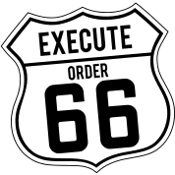

Monitoring System Specification

March 27, 2017

Project Description

The purpose of the product is to create a monitoring system for devices connected to a network. It will be a web application created using PHP and JavaScript languages and will able to run on multiple devices including desktop browsers and smart-phones. The monitoring system will gather information from a variety of IoT devices that are connected to a single network and displayed to the user. Smart IoT enabled devices, such as light bulbs, fridges and energy systems will be displayed in a list on the application with their past and status for investigation.

Our team will be testing and demonstrating our project by designing and producing a networked prototype using stub methods. The application will simulate IoT devices using both mobiles and desktops which will hold test data that can be sent to the application. Furthermore, we will gather test data and display it as if it was gathered from an IoT device.

Our application will be designed to allow devices to be added and dropped from the network without influencing the system's functions. We will also build the application with thought on sustainability, maintainability and expansion. Our interface will not be limited to a set number of devices even though we will only be testing with three. We aim to have several visualisation functions such as usage over time and graphs using the data provided.

Design Goals & Requirements

The application aims to achieve the following targets:

* Application must take in information from multiple IoT devices.
* IoT device information to be displayed successfully to the users.
* Giving users the ability to view the list of devices they have and investigate their device status.
* Application able to grow in the future by allowing standard users to add new devices.
* Allow at least three devices to be monitored at a time.
* Contains no dead elements such as unused buttons and links.
* Allow users to see trends in the system over time for each device.
* Application working on multiple devices (PCs and Smart-Phones)

We want the interface of the system to be intuitive for all users, we also want the application to be accessible so that it caters with disabilities and other impairments. We can do this by making the aesthetic of each webpage to easily differentiate between one another instead of relying on colours. Furthermore, we will use a colour scheme that is easier for visually impaired users.

Target Market

Our ideal user has the following characteristics:

* Families with high income
* Ages 10+
* Have Smart Devices available in their home
* Users that have high interest in IoT devices

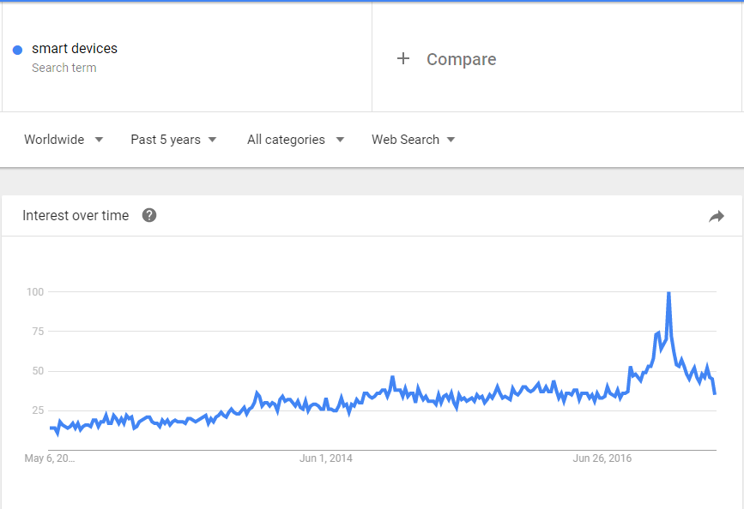

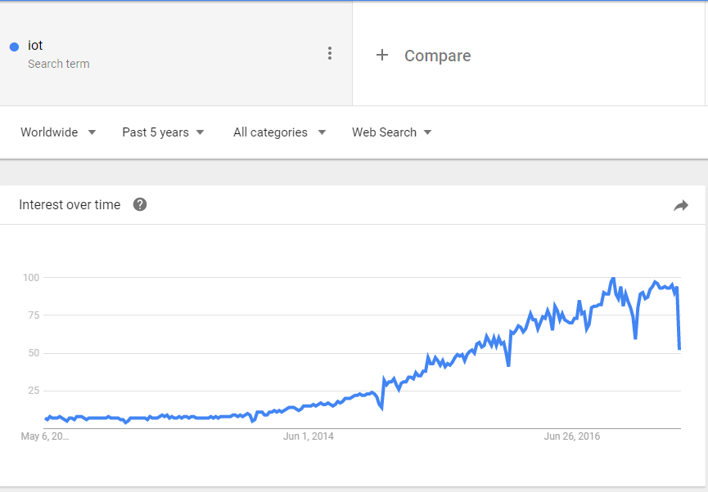

There are several different services that have helped us accumulate data about similar markets including Google Trends and Flurry. These sites have assisted us in pulling relevant data to make an application that meets the user requirements as best as we can. On both graphs above, the number of searches on Google for “smart devices” and “IoT” is increasing as the years go by. This verifies that our product will have a large, growing audience.

SURVEYS

To gain a better understanding of customers in our market, we created a survey which was given to 100 people of different ages. The main purpose of the questions, is to understand how aware/educated the public are regarding IoT platforms and devices.

The survey consists of 8 questions which are themed around people’s knowledge of current IoT devices/platforms, as well as recently released or future development smart devices. The questions are:

1. What age group are you in?

2. How interested are you in technology?

3. What smart devices do you own?

4. Which of these smart devices do you own/would you like to own?

5. What devices have you used to access the internet?

6. Do you believe that there are too many smart devices on the market?

7. What is the most you would spend on a recently released smart device? (£)

8. Do you have a household or wearable smart device which has a supported application?

COMPETITIVE ANALYSIS

There are many platforms for IoT controllers available to buy now. These are devices or applications that facilitate data transfer between multiple devices or applications. Although this form of smart device may only be a recent development, there is already a variety of devices which cover many different industries.

One device and application which is not dissimilar to our system, is the Amazon Echo. This is a smart speaker which runs alongside multiple compatible platforms. This smart speaker was released in June 2015, and has become widespread throughout the United States and Europe, selling more than 15 million devices as of January 2017.

The Amazon Echo works by operating from the user’s voice commands and interactions with the supported mobile application. From this app, you can synchronise your Echo with many different devices, such as the LIFX smart-bulbs or the Jawbone UP2 band. By doing so, the Echo (or Alexa, as the interface is known) can send notifications to your smart devices regarding changes in the devices’ state. You are also able to control other devices with Alexa’s voice recognition. For example, you could say to the Echo “Alexa, turn on my lights”, to which the Echo would signal the LIFX bulb to turn on. The interchangeability and compatibility with other devices and applications, is customized from the Echo application. The Echo is also becoming more advanced, as software patches are adding compatibility with other devices and applications.

In terms of our system, this form of compatibility and scalability is essential for our web application. We’d also want our system to be similar in terms of its ability to seemingly ‘learn’ from data it receives. Our system must be able to import data from 3 or more devices, so the Echo’s ability to synchronize with multiple devices is an ability that we’d similarly need to implement.

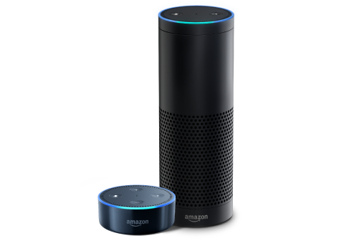 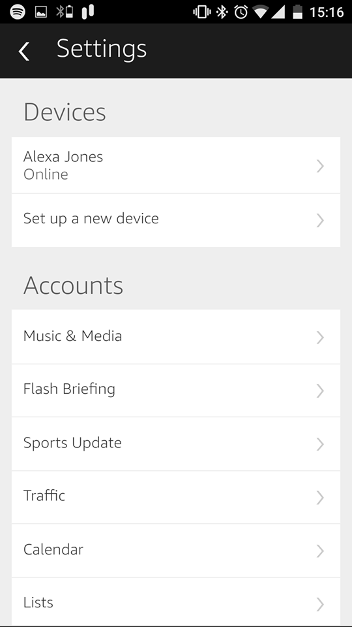 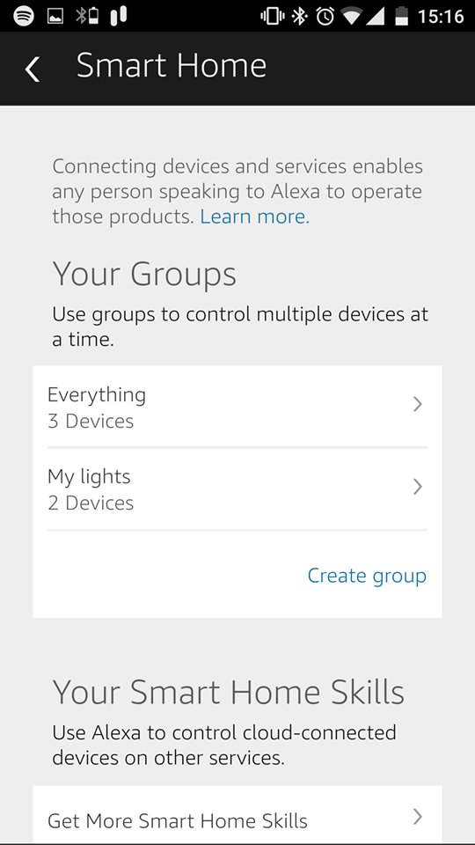

An example of an IoT application is the IFTTT (If this, then that) which is a smart device application for creating ‘recipes’. This application takes data from multiple devices, such as the Nest thermostat, so that it can run functions for other devices. For example, if the IFTTT application is synchronised with Amazon Echo and LIFX bulb, then you could create the ‘recipe’ for the LIFX bulbs to turn BLUE when the phrase “Alexa, turn my lights BLUE”.

We’d want our web app to have similar connect ability, but for monitoring rather than acting upon that data. Given that we are creating an application rather than a supporting device, this application, even if it is mobile, is a good backbone to base our design concepts on. We’d want to match this level of compatibility with other devices, even if we don't necessarily have any function other than monitoring the data.

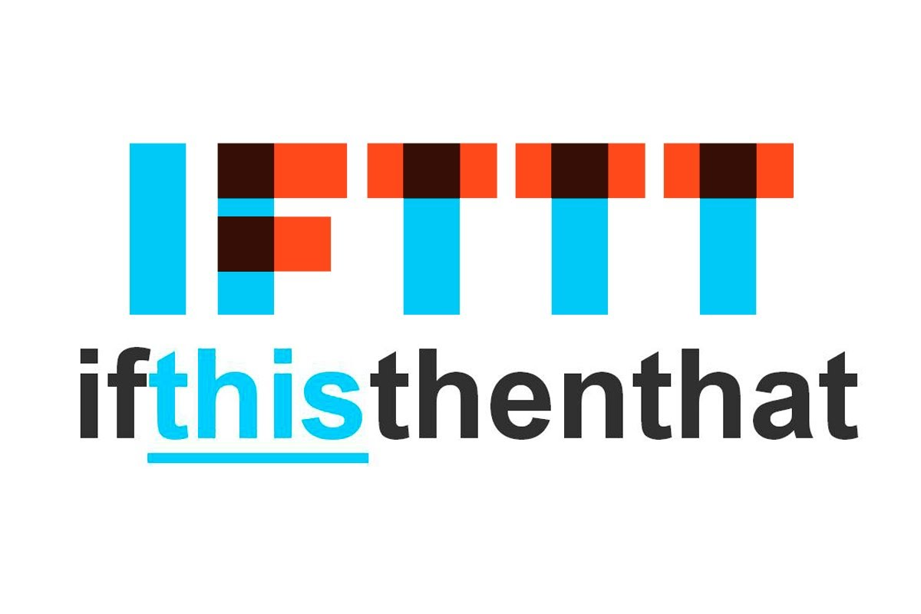 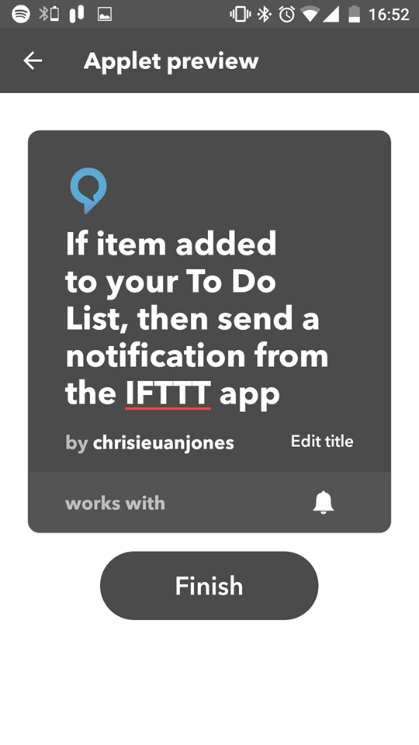 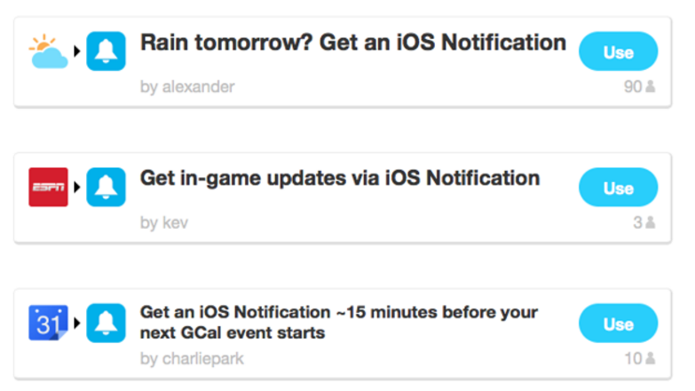

Additionally, an example of an IoT device that we could use in our system is the Nest Learning Thermostat. This thermostat is designed to be controlled from your phone, so that you can warm up your house before you get home/turn it off when you leave the house. The actual device consists of an electronic display for changing the temperature of your house, which also consist of options that allow it to be synchronised with its corresponding smart device to offer the application.

This device operates by changing the temperature levels of a device (normal boiler) from data that it receives from a smart device application. This form of functionality between devices is something that we could use, although to reiterate, our system would consist of monitoring data changes, not necessarily acting upon the data that is received.

DESIGN CHOICES & SCREEN DESIGNS

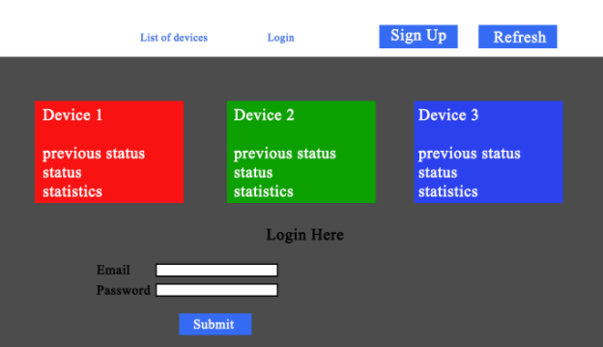

This is the screen the user is first presented with. The device list will be displayed as buttons and will re-adjust depending on how many devices are present on the network. Each device’s button will display status information about the device and when pressed will navigate the user to a statistics page allowing the user to monitor the device further. a sign in button which will move the user to the bottom of the page to allow them to sign in and claim devices. A refresh button is also available to update the device list.

A Login system would be used so that each user can use all the features of the application when not connected to the network. The user will able to monitor the data of each device as long the smart devices are connected to same network as the device running the monitoring app. If the user has registered they will be able to claim new devices and remove any unwanted devices on the network.

A pop-up will appear when the user clicks on the sign-up button. They will have to enter their email address and their password. The email entered will be used as their user name, which will be used to login in.

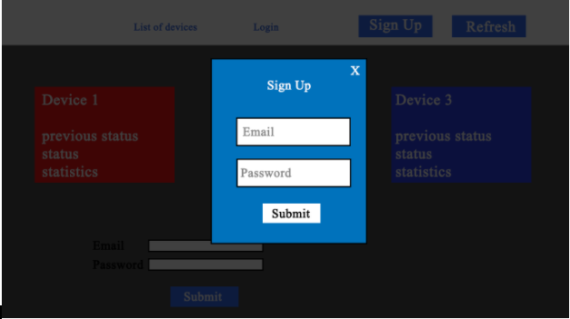

As part of our design we have decided to provide details about the status of the device. The application will how data in a graph format. The graph will show the times the smart devices are active. The user will be able to monitor the energy consumption. They would be able to look at previous status of each device so that they can see if there is any improvement. Stats of device such as uptime, usage and various data are collected.

# TEST CASES + TEST PLAN

We have created a thorough test plan to ensure that the system we create is functionally working and of the best quality. We also need to make sure our site is secure so will be searching for exploits throughout the code this will be performed through white box testing.

These tests will be attempted throughout design and more thoroughly at the end of our implementation.  The functionality will be tested through black-box testing.

|  |  |  |  |
| --- | --- | --- | --- |
| Test No | Purpose | Test | Expected Result |
| 1 | Select a device and check if all statistics show up | Select device ‘Alexa’ and press the stats link. | The statistics of the selected devices will open. |
| 2 | Security check against injection (both white & black-box testing) | Attempt multiple security breaches on the site. Make sure all forms are secure and do not allow for injection. PHP application server should be hidden. | We are expecting to find a few security problems. But none that will be difficult to rectify. |
| 3 | Turn device off and check if it turns off on the website | Turn the device on and check if the device is displaying as enabled on the site. Turn the device off and reload the site and check if the device is still visible as an enabled device. | Expecting the website to stop displaying the device as enabled once the user turned off the device. |
| 4 | Accessing each webpage effectively | Check all links are live. | User able to access every link as planned |
| 5 | User Login with Invalid Data | Attempt to login with incorrect credentials. | User attempt to log onto the site using invalid data and the site refusing user access |
| 6 | User Login with Valid Data | Attempt to login with correct credentials. | User attempt to log onto the site using valid data and the site allowing user access |
| 7 | Signing up with Invalid Data | Sign up to the website with incorrect data:  -empty form  -incorrect email format | User attempt to sign up to the site using invalid data and the site refusing user access |
| 8 | Signing up with Valid Data | Sign up with valid and correct data | User attempt to sign up to the site using valid data and the site allows user access |
| 9 | All Bootstrap elements work on site | Make sure redundant code is cleared and all code is utilised. | Expecting to contain no dead bootstrap elements in the system |

# FLOW CHART OF THE MONITORING APPLICATION

The functional logic of the application can be seen through this flow chart: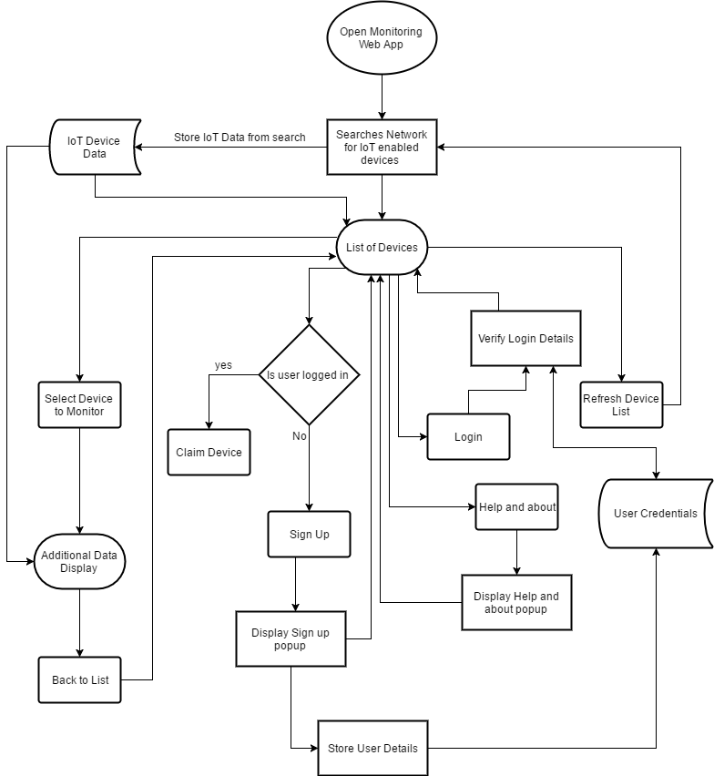

BIBLIOGRAPHY

<https://www.amazon.co.uk/Amazon-SK705DI-Echo-Black/dp/B01GAGVIE4>

<https://www.lifx.com/>

<https://ifttt.com/>

<https://jawbone.com/fitness-tracker/up2>

<https://trends.google.co.uk/trends/explore?q=iot>

<https://trends.google.co.uk/trends/explore?q=smart%20devices>